**CSCE 560**

**Wireshark Lab 1**

**15 Oct 18**

**Marvin Newlin**

1. List 3 different protocols that appear in the protocol column in the unfiltered

packet-listing window in step 7 above.

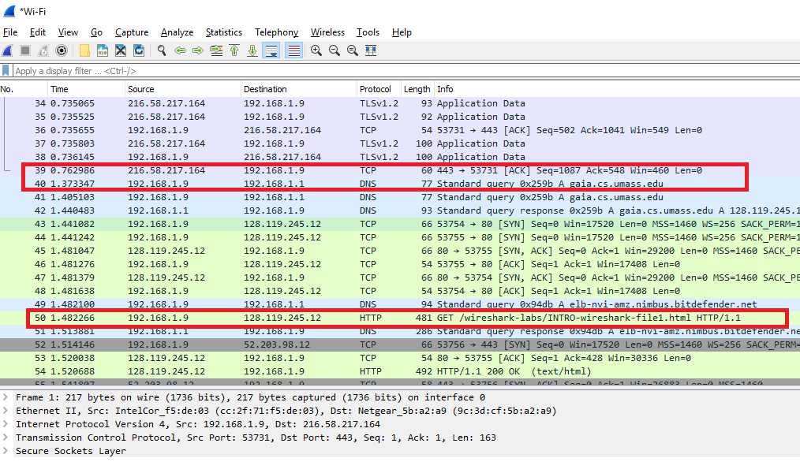

As we can see from the packet listings, we can see packets from TCP, DNS, and HTTP protocols.

2. How long did it take from when the HTTP GET message was sent until the HTTP

OK reply was received? (By default, the value of the Time column in the packetlisting

window is the amount of time, in seconds, since Wireshark tracing began.

To display the Time field in time-of-day format, select the Wireshark *View* pull

down menu, then select Time *Display Format*, then select *Time-of-day*.)

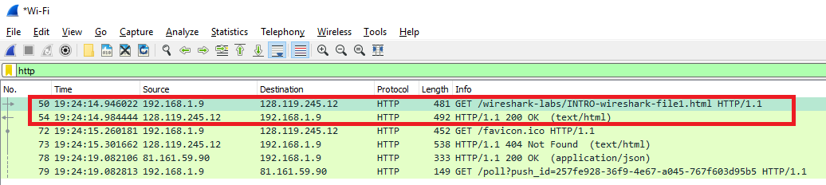

As we can see from the time values above it took 0.038422 seconds or 38.42 msec for the OK reply message to come in.

3. What is the Internet address of the gaia.cs.umass.edu (also known as wwwnet.

cs.umass.edu)? What is the Internet address of your computer?

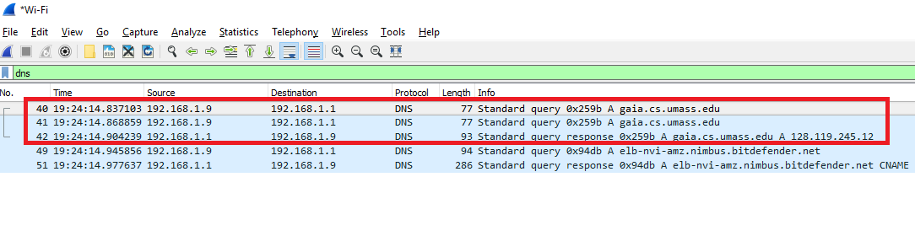

In frame 40 we see the source IPv4 Address of my computer which is 192.168.1.9 and in frame 42 in the DNS Response we see that the IPv4 address of the website is 128.119.245.12

4. Print the two HTTP messages (GET and OK) referred to in question 2 above. To

do so, select *Print* from the Wireshark *File* command menu, and select the

“*Selected Packet Only”* and *“Print as displayed”* radial buttons, and then click

OK.

See the attached pages.